Remote DNS Attack (Kaminsky Attack) Lab

Lab Environment Setup Tasks

Task 1: Configure the User VM
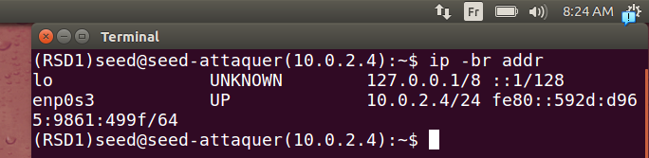
.attacker machine ip address
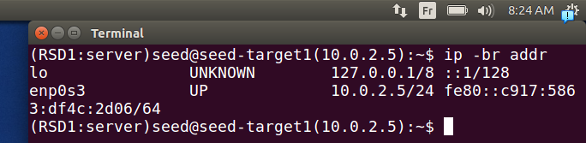
.server machine ip address
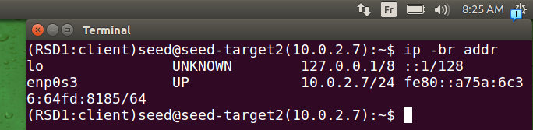
.ip address of client machine
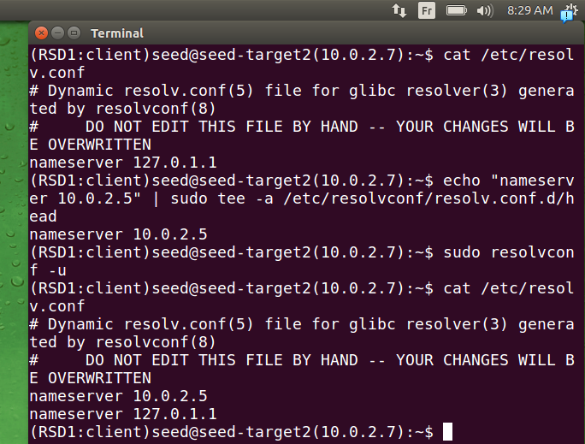
.here we show the file before configuration it contained only the address of the dns cache resolving address, then after adding the address of our local dns server address and refrching the configuration the address 10.0.2.5 been addred succefully
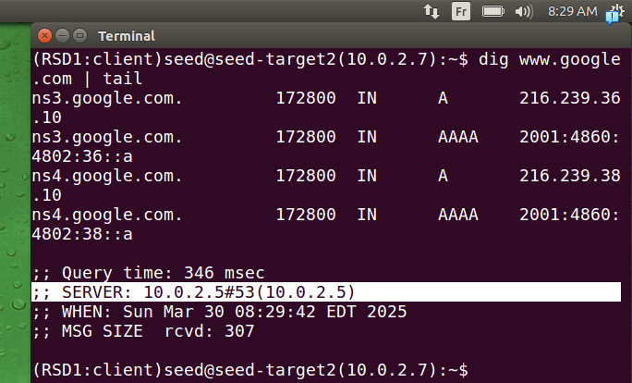
.here we use dig command to test our configuration it works fine the client machine interogate the local dns server machine we wanted

Task 2: Configure the Local DNS Server (the Server VM)

Step 1: Remove the example.com Zone.
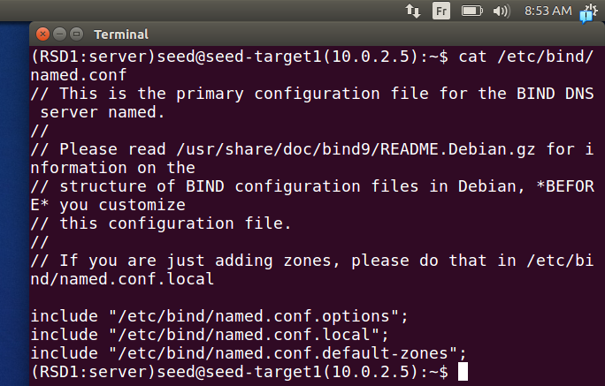
.here we have removed the zone as mentionned.

Step 2: Set up a forward zone.
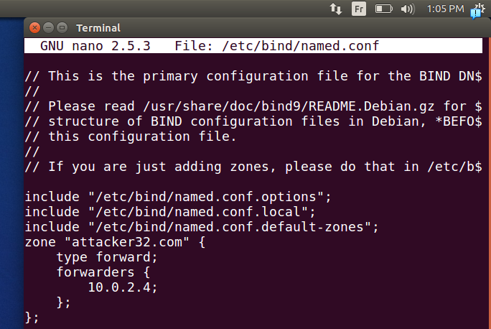
.here we configure the server so it forward querries directly to attacker machine.

Step 3: Configure a few options.

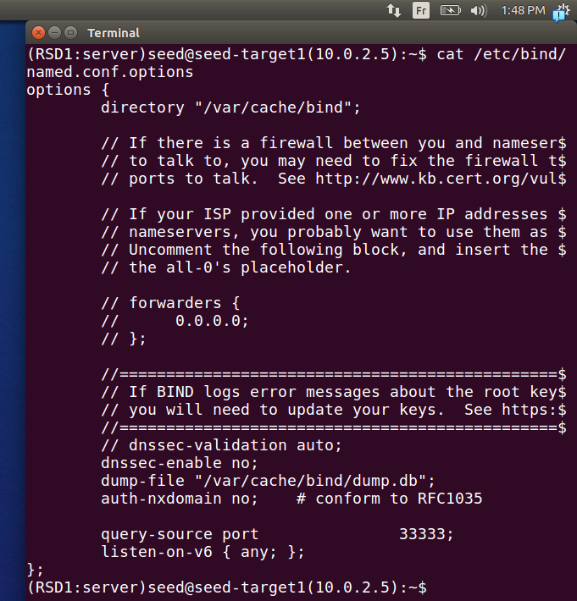
.as said no configuration needed but we need to mention what we learned configuration done by the ssedLabs is:
they chosed file to dump the cache into it if wanted.
They also fixed the source port for simplicity
and they stopped the security feature of bind(dnssec)

Step 4: Restart DNS server.

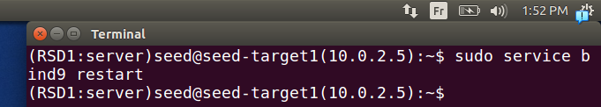
.here we restart the dns server as mentionned to apply the modification(it’s needed as said)

Task 3: Configure the Attacker VM
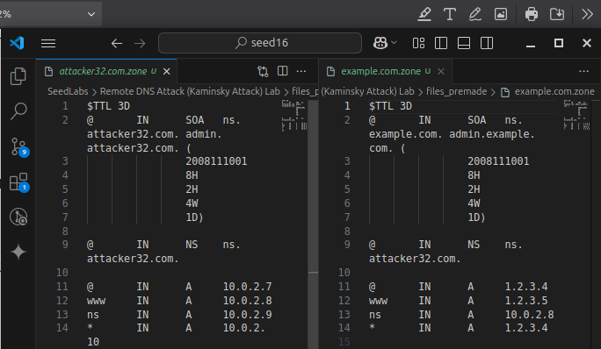
First we downloaded the files as mentionned
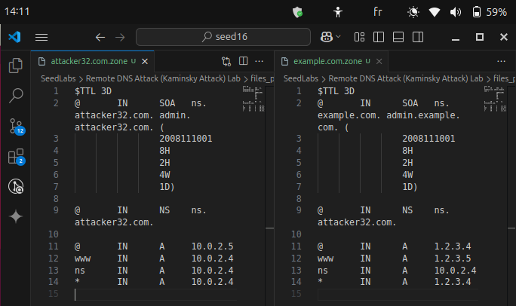
then we modified them according to our ip addresses(we differ from the step)
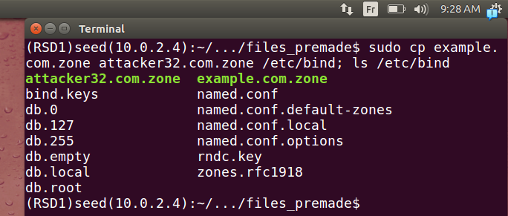
we copy them as mentioned
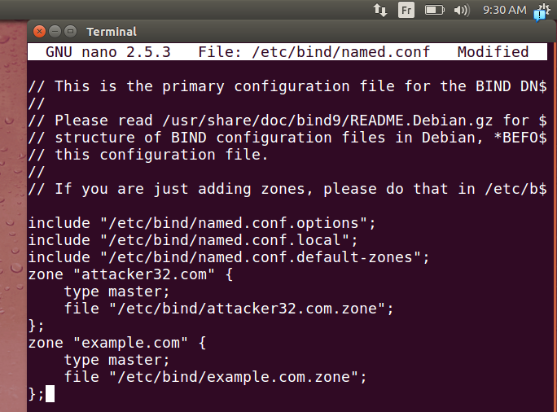
then we add the zones in the file also(we’re just following instructions)
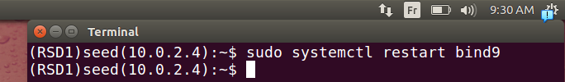
then we restart so configuration is updated

Task 4: Testing the Setup
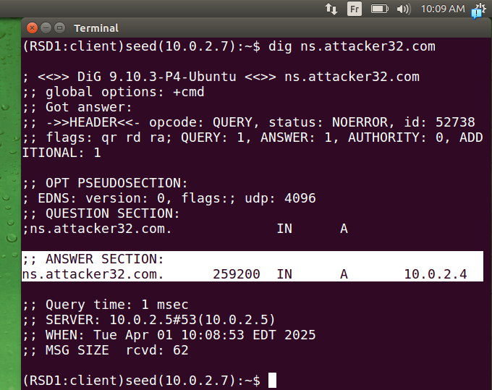
.here if we dig attacker32.com as mentioned we will get as we put in the file of attacker machine the reponse comes from the local dns server
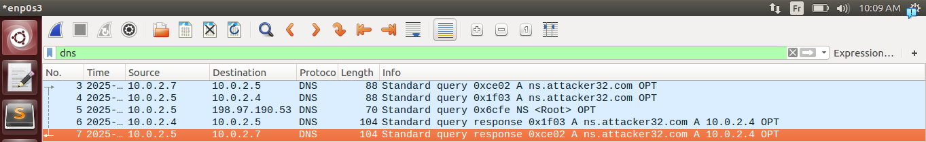
.if open wireshark and capture the traffic we could see clearly that our querry got to the local dns server first (packet 3) then it goes to attacker machine because we configred it earlier(packet 4), packcet 5 is because it asks multiple servers (any) (packet 5), response comes from attacker machine (packet 6), then response to client(packet 7)
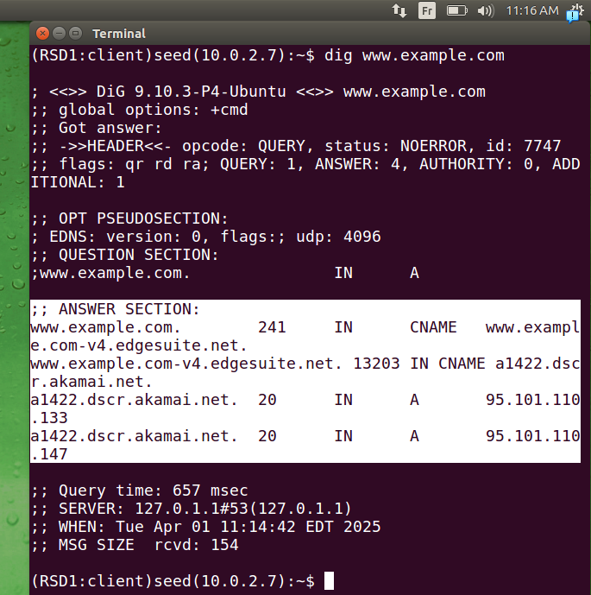
.if we dig before the attack this test shows that it failed
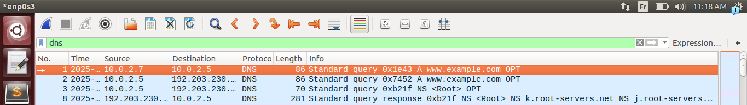
.we can see it clearly in wireshark, we querry the local dns server, it asks the right way, then a right response comes, nobody is asking the attacker machine because we didn’t do the attack yet
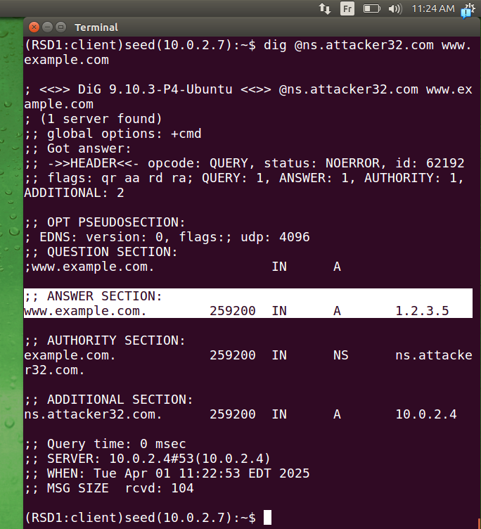
.just to show the attack will succeed after the poissining, if we dig directly through the attacker machine we will get a response as mentionned before, with more sections as athority and additional configured alredy in attacker machine
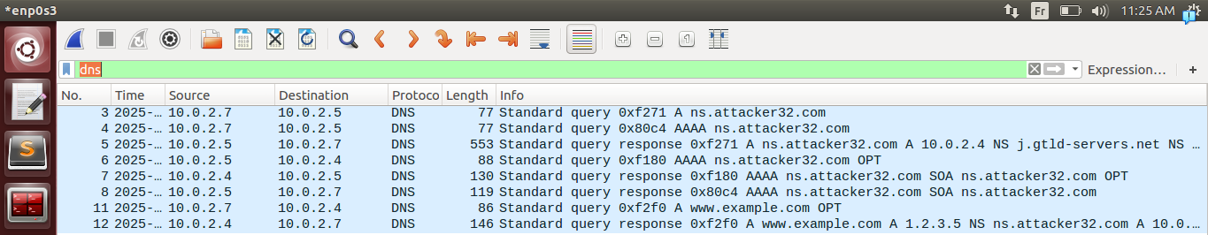
.the response can be justified through wireshark packets captured, a querry to dns local server searching for the attacker attacker name server’s address(packet 3, 4), then a reponse means the correct ip for ns.attacker.com(packet 5), then asking for ip6 address(AAAA)from local dns server(packet 6-8), now client asking directly after getting the address the machine attacker and gets the false response as we wanted, this concludes that the configuration is working fine we can proceed in our attack.

The Attack Tasks

Task 4: Construct DNS request
.
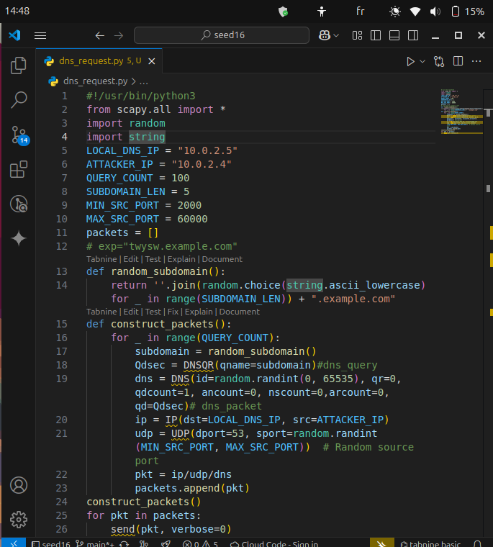
.for making the code we used the skeleton given and using the diagram given already we made the code, note that for we are separating the code for clarity and optimization purpose
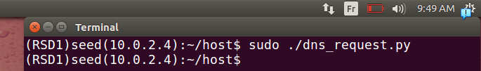
.if lunch our script
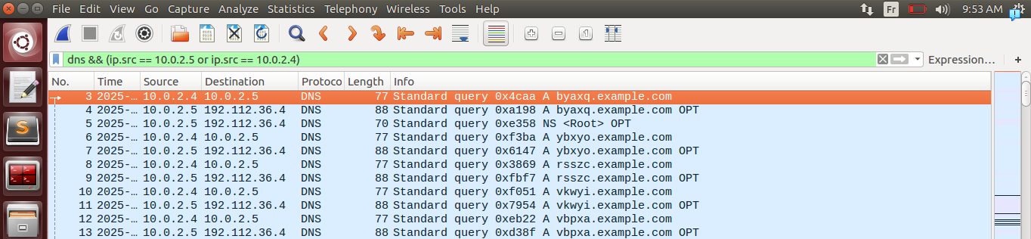
.we can see the querries from attacket→ local dns server, then it triggeres the local dns server to ask other servers
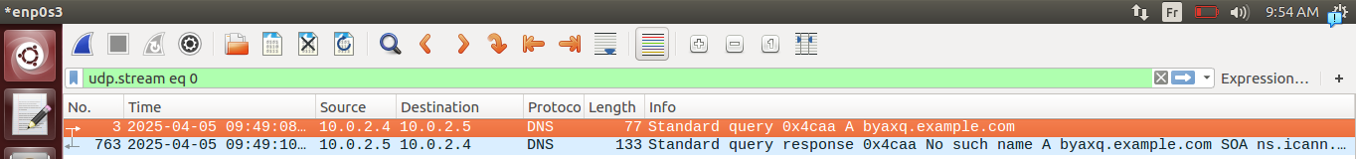
.here if we follow first querry it took arround 2 second to resolve to no existing subdomaine(so we must take that time in consideration later on)

Task 5: Spoof DNS Replies.
.
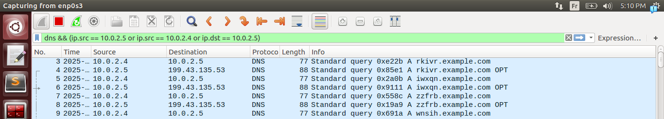
here you can write a script based on the image (this one is after running the script on task 4 again those addresses of authorative server asked are changing from b.iana-servers.net: 199.43.133.53 , and a.iana-servers.net: 199.43.135.53) this is the correct approch but we can’t say that it’s really going to work but we can verify it aproximitly from wireshark in the next test. Chosing the address is crutial
.
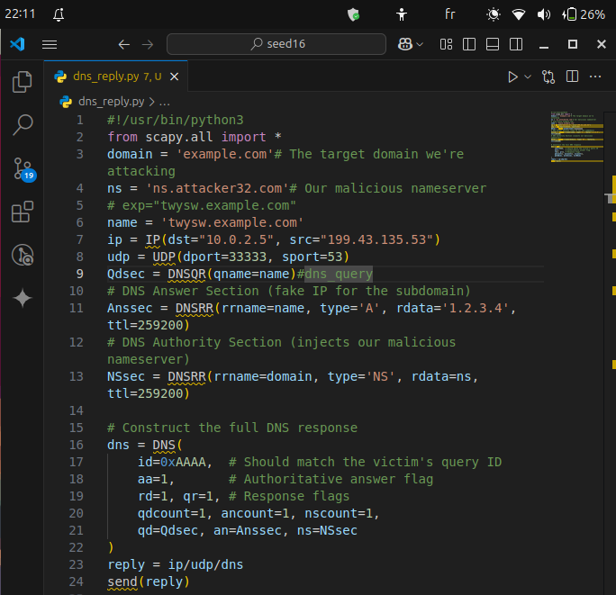
the code we chosed to use a.iana-servers.net: 199.43.135.53 hoping that’ll will be correct later on
.
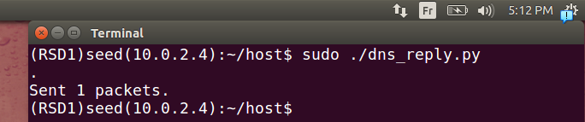
.if we lunch our script
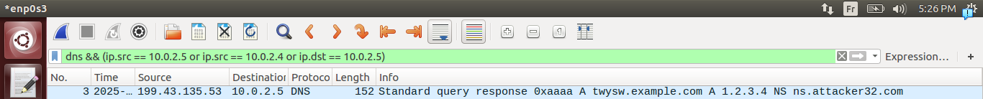
.we can see that it seems that it works fine.
Just to make sure that it works correctly we give it a try locally to see if it’s really going to work if we predict correctly the id
.
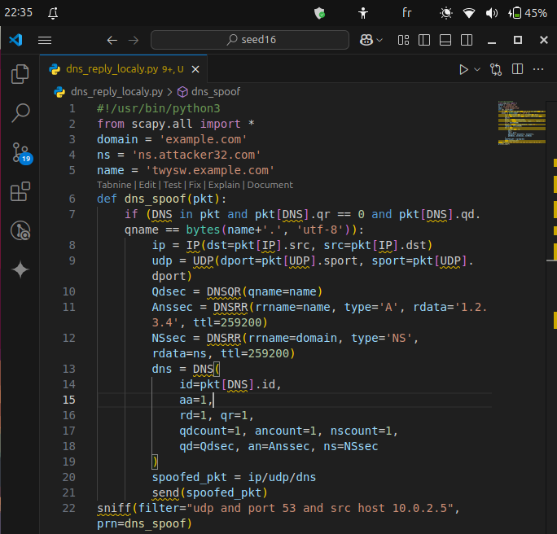
.we put it in sniff so we could see the authorative server(src ip), and the id of the transaction, same logic just for test
.
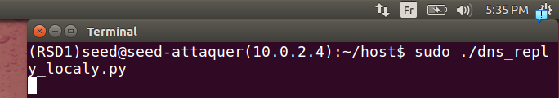
. if we lunch this script
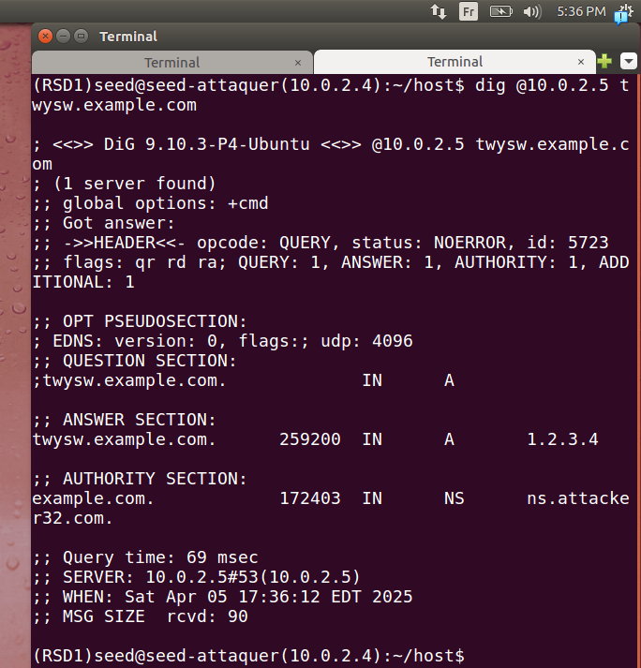
.and try to dig we could see that it works fine
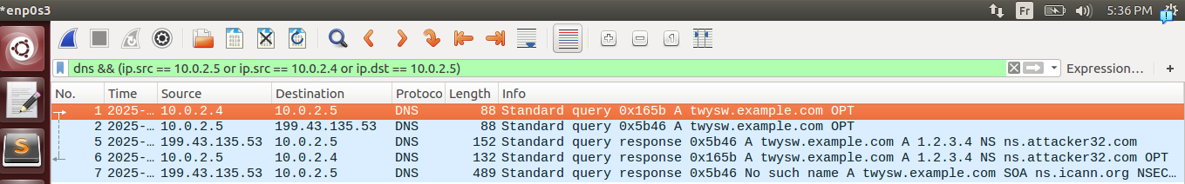
.just for demonstration
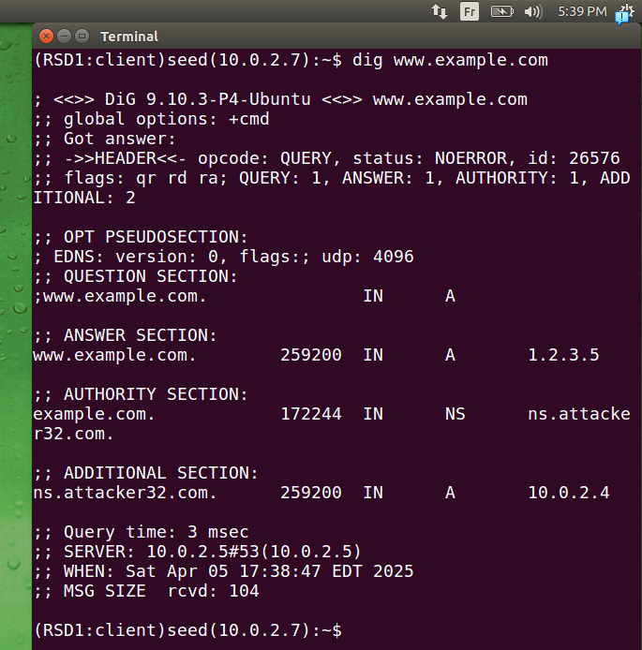
.and in client side it’s working
Note that it’s just for testing purpose(we did it localy knowing the 2 of information critical)

Task 6: Launch the Kaminsky Attack.
.
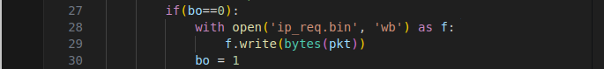
.here we added this to the request so it saves only one instance of packet
.here we also added it to the reply
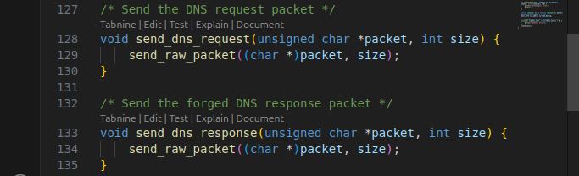
.in the code given we just used the function predifined to send the packet
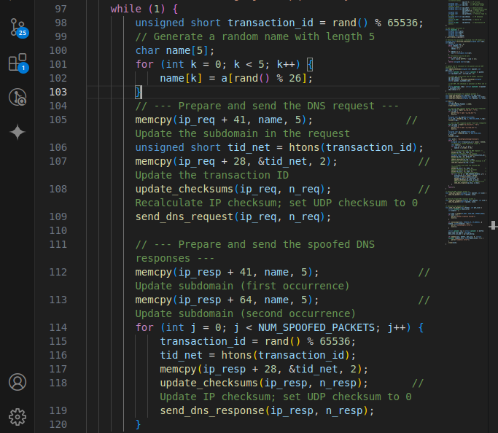
.for each time we randomly generate an id of transaction and a random subdomain to be modified in the packet deja captured (iq_request.bin) then we send it, now for this packet we test randomly id_transaction 14000 packets(C is so fast), in those packets response (the one captured earlier we modify the querry section, and the response section as montionned). Note that the bigest problem we must take on is the checksum update we will see it later on
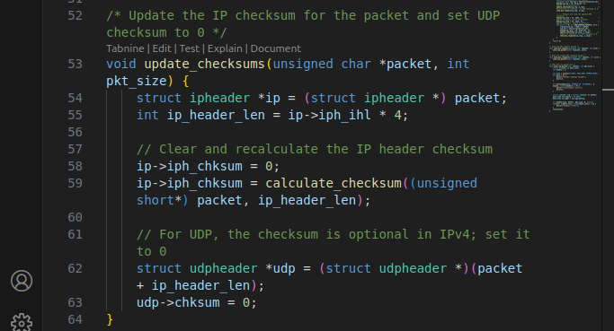
.here for the checksum we have two ip, udp for the 2 layers, because it’s udp, the udp checksum = 0(because optional) but ip is obligatory
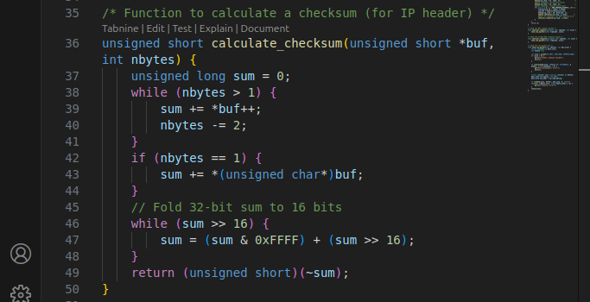
.we calculate it as mentionned in 1st tp, sum 4 bytes than the additional one if exist it’s summed to the right and so on for all bytes than inverse and that’s it.
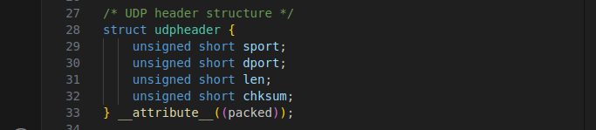
.we define udp header
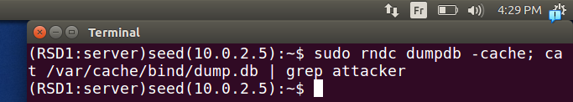
.right now no poisining can be seen
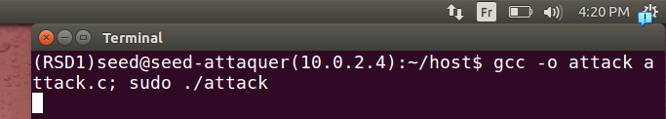
.if we lunch our script
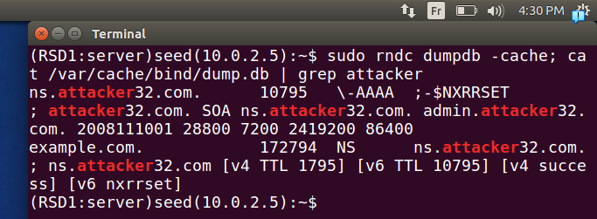
.we can see after 1 minute(it’s less than that) that it got poisened

Task 7: Result Verification
.
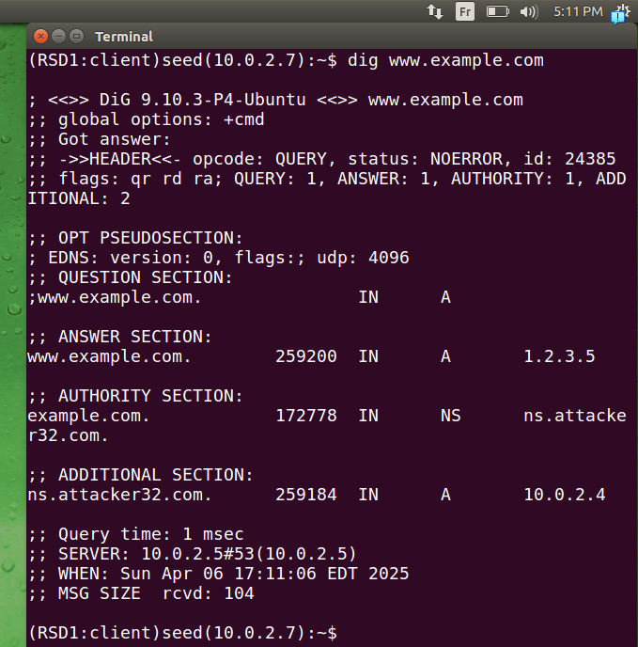
.we can verify it through the client
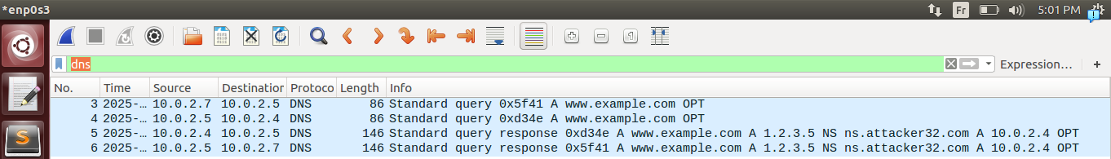
.here because it’s poisened and the first time no cache on local dns server it’s seeing it as an authorative server so it’s querrying it
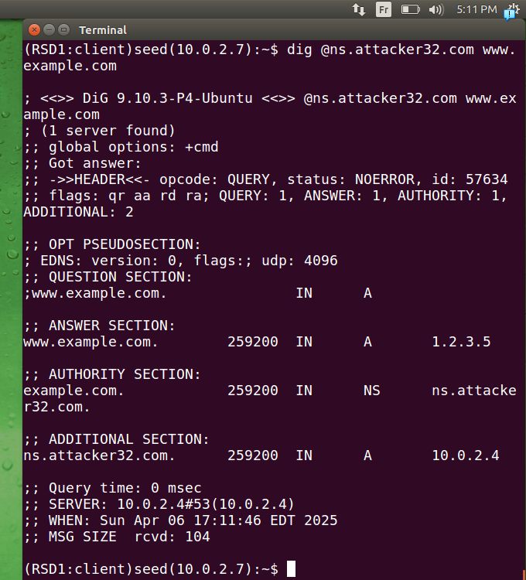
.if we lunch it directly also it’s working
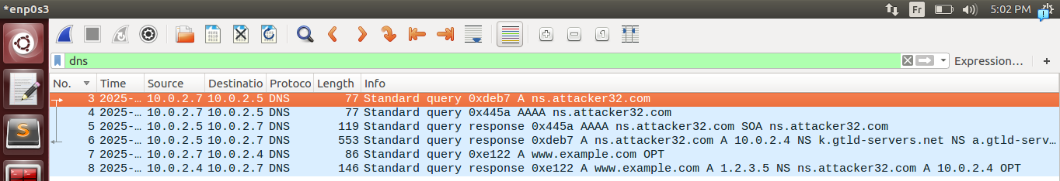
.we can see it clearly in wireshark

